JMeter Beginner Tutorial 9 - How to run jmeter from Command Line (non GUI mode)

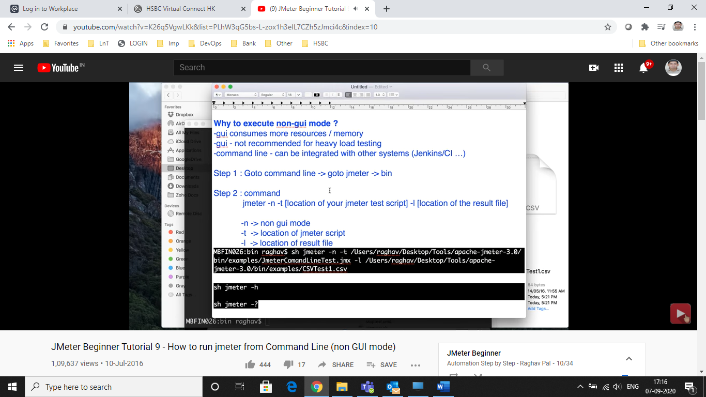

Jmeter -h

Jmeter -?

# JMeter Beginner Tutorial 11 - Testing Web Services API

Add Thread group > Add HHTP Request (Sampler)

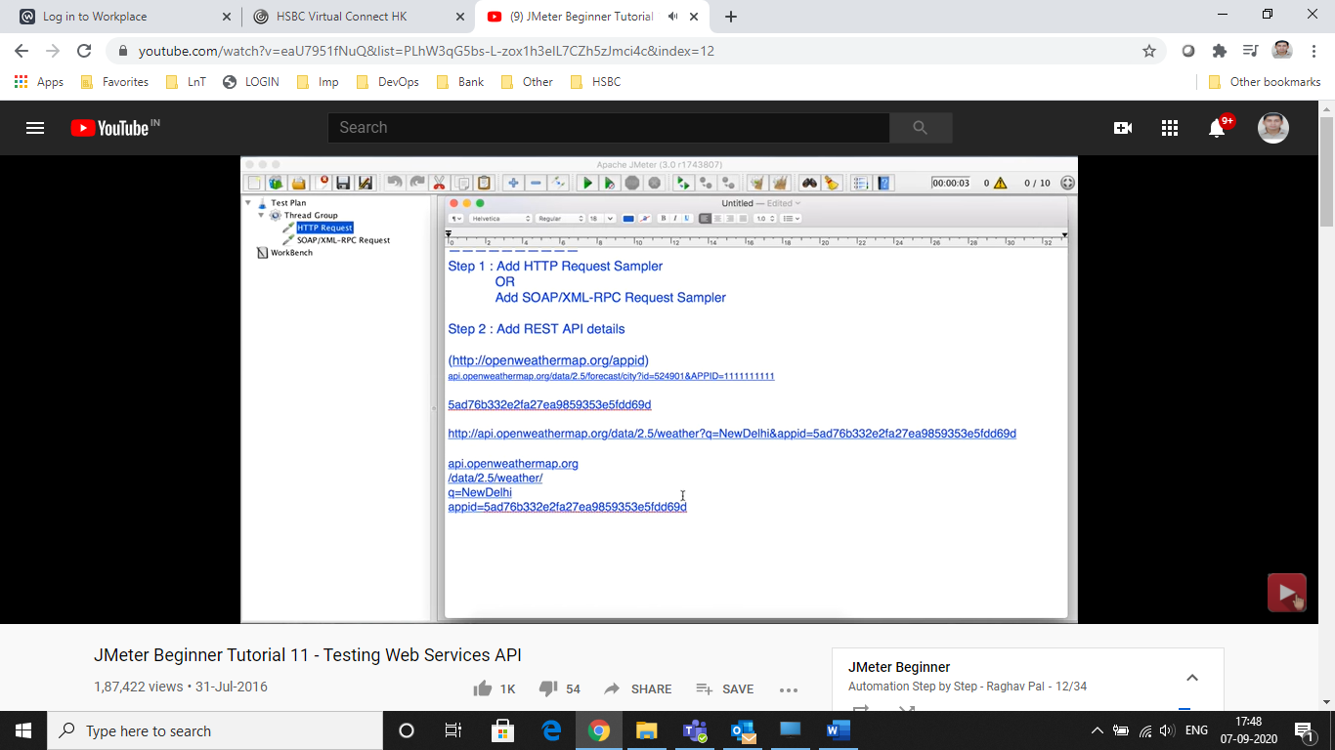

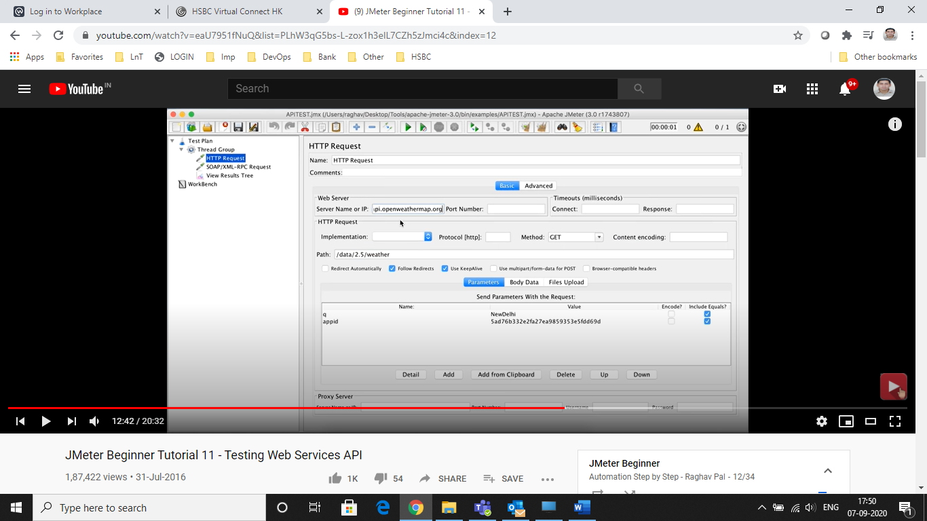

# JMeter Intermediate Tutorial 4 - How to generate Graphical results

<https://jmeter-plugins.org/?search=jpgc-ggl>

<https://jmeter-plugins.org/?search=jpgc-cmd>

zip files > unzip it > you will get lib folder > ext > .jar file

put that inside ur home directory > jmeter home dir lib ext folder

